**BINARY TO DECIMAL CONVERSION**  
**EXP NO: 26**

**AIM:** To write a C program to implement binary to decimal conversion.

**ALGORITHM:**  
1)      Start  
2)      Read the binary number from the user, say ‘n’  
3)      Initialize the decimal number, d=0  
4)      Initialize i=0  
5)      Repeat while n != 0:                                                               
i.     Extract the last digit by: remainder = n % 10                                                             
ii.     n = n/10                                                           
iii.     d = d + (remainder * 2<sup>i</sup>)                                                           
iv.     Increment i by 1  
6)      Display the decimal number, d  
7)      Stop

**PROGRAM:**  
#include<stdio.h>

int main()

{

int num, binary_num, decimal_num = 0, base = 1, rem;

printf (" Enter a binary number with the combination of 0s and 1s \n");

scanf (" %d", &num);

binary_num = num;

while ( num > 0)

{

rem = num % 10;

decimal_num = decimal_num + rem * base;

num = num / 10;

base = base * 2;

}

printf ( " The binary number is %d\t", binary_num);

printf (" \n The decimal number is %d\t", decimal_num);

}  
**INPUT:**  
  
  
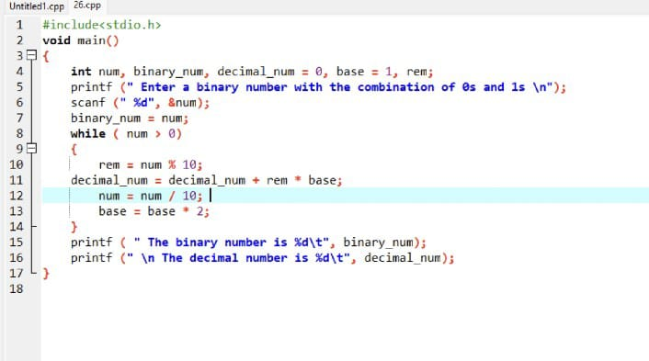  
  
**OUTPUT:**  
  
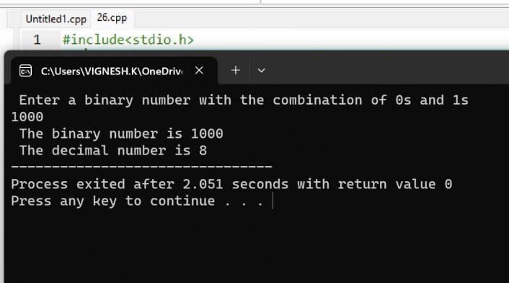  
   
  
  
   
  
  
   
  
  
  
  
  
**RESULT:**

Thus the program was executed successfully using DevC++.